**Lab#2- Solidification, Microstructures, and Phase Diagram Development of the Al/Cu System**

Edward McGarry

11/26/2019

Alec Anderson, Colin Arbuthnot, Garrett Marlowe

MSE3333 Thursday 3p.m.

**Abstract**

The microstructures of pure Aluminum and Al-33wt.% Cu line up with their predicted and counted volume percent. Al-15wt.% Cu and Al-4wt.% Cu differ between their counted and predicted values. The difference in the Al-15wt.% is minor and is likely due to a small deviation the local microstructure. The Al-4wt.% Cu has a counted and predicted vol. % alpha of 94.5% and 95% respectively. This difference agrees with a shift due to coring. Al-40wt.% differs significantly from its predicted volume fraction. Theta was counted to be 58vol.% versus the predicted 33vol.%. This departure from the predicted value is due to an unrepresentative local microstructure compared to the whole.

Cooling data for the samples was collected. This data was used to generate a partial Al/Cu phase diagram. The melting point of pure Aluminum and the eutectic temperature for the cooling curves for the generated Al/Cu phase diagram agree with the published phase diagram. However, solidus and liquidus temperatures on the cooling curves are low compared to the published Al/Cu phase diagram. This error is due to coring shifting the phase diagram away from the eutectic composition on both sides.

**Introduction**

There are many elements that can be alloyed with Aluminum, however this experiment focuses on the 2XXX series, which is an Aluminum alloy with Copper. The 2XXX series is used in aircraft skin, rivets, and military vehicles for its strength, ductility, and its ability to be precipitation hardened. This experiment looks at a casted Al/Cu system and how differing amounts of Copper change the microstructure. Different phases are identified, along with their respective volume fractions. Using cooling data that was collected during solidification a partial phase diagram is generated. This generated phase diagram is compared to a published phase diagram of the Al/Cu system to see how non-equilibrium cooling impacts the generated phase diagram.

Cooling curves are a plot of the temperature of the cooling sample as time passes. At temperatures where phase transformations initiate there are portions of the curve that are isothermal. This is due to the evolution of latent heat at the phase transformation temperature for a given composition. As a result of these isothermal regions, a temperature for each phase transformation can be determined. If the sample is cooled from molten material the first phase transformation, will indicate what temperature the liquidus is at. The liquidus is where solid begins to precipitate out of the liquid solution. The next line is where the last of the liquid solidifies, otherwise known as the solidus. Cooling curve data can be extremely useful, however, to obtain the most accurate data, a long cooling time is required. A longer time allows for more diffusion to take place, which is needed for equilibrium cooling. Non-equilibrium cooing will lead to coring in the Al/Cu system, which will cause an inaccurate phase diagram.

Phase diagrams are used to predict the weight fractions and phase composition of resulting solids of a known weight % solute. Calculating the expected weight fractions of the phases can be done using the lever rule. These diagrams are generated using cooling curves for many samples of Al/Cu, with gradually increasing amounts of Copper for this experiment’s sake. The cooling ideally takes place over a long period of time to allow for equilibrium cooling to take place. When cooling at the phase transformation boundary temperatures heat is released. This causes a flat region to appear on the cooling curve. Using these points for many compositions of the Al/Cu under equilibrium cooling conditions an exact phase diagram can be generated. Under non-equilibrium conditions the phase diagram will be shifted due to coring.

Volume fraction analysis can be used to show the differences between equilibrium and non-equilibrium cooling. A micrograph with a 10x10 grid superimposed on top is used. The amounts of each desired phase are counted and compared to what the expected volume percent is. This is done by using the Al/Cu phase diagram and converting expected mass percent to expected volume percent.

**Procedure**

5 samples of Al/Cu were gathered: 0wt.% Cu, 4wt.% Cu, 15wt.% Cu, 33wt.% Cu, and 40wt.% Cu. Each sample was then individually melted and cast into a crucible with an imbedded thermocouple to record the temperature of the Al/Cu as it cools to at least 350℃. The samples were then prepared for microscopic evaluation. Each sample had its microstructure identified, except the pure Aluminum which only had its microstructure identified. Micrographs using the 10x and 50x scopes were taken. Next, the cooling curves were used to create a partial phase diagram. The composition of the sample is a given, and all phase transformations occur at any location where the cooling curve stays at a constant temperature for a visible amount of time. These temperatures and compositions can be used to then plot points on a partial phase diagram. Next, the points are connected, and the regions labeled to finish the partial phase diagram. Using the 50x micrograph for all samples, except the pure aluminum, a 10x10 grid was overlaid. Using this grid, a volume fraction analysis for each sample was completed. Then these found volume fractions were compared to the predicted volume fractions using the phase diagrams converting expected phase percent to volume percent. Using the collected data an analysis of the Al/Cu system microstructure and phase diagram can be completed.

**Results**

|  |  |  |  |  |  |  |  |  |
| --- | --- | --- | --- | --- | --- | --- | --- | --- |
|  | Al-40wt.% Cu | | Al-33wt.% Cu | | Al-15wt.% Cu | | Al-4wt.% Cu | |
|  | Theta | Eutectic | Alpha | Theta | Alpha | Eutectic | Alpha | Eutectic |
| Predicted | 33 | 67 | 51 | 49 | 72 | 28 | 95 | 5 |
| Counted | 58 | 42 | 51 | 49 | 74 | 26 | 94.5 | 5.5 |

*Table 1: predicted volume fractions and the found volume fractions.*

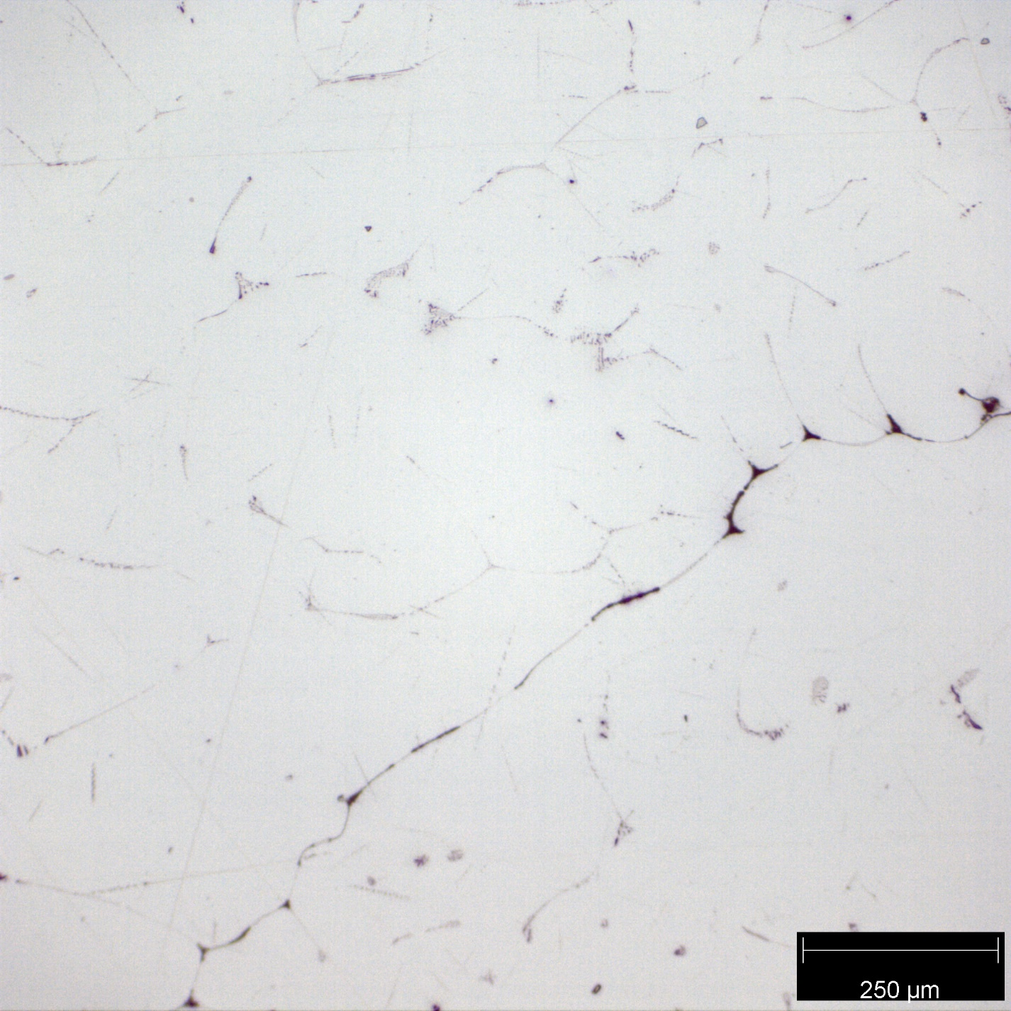

*Figure 1: Pure Al micrograph taken with the 10x scope.*

*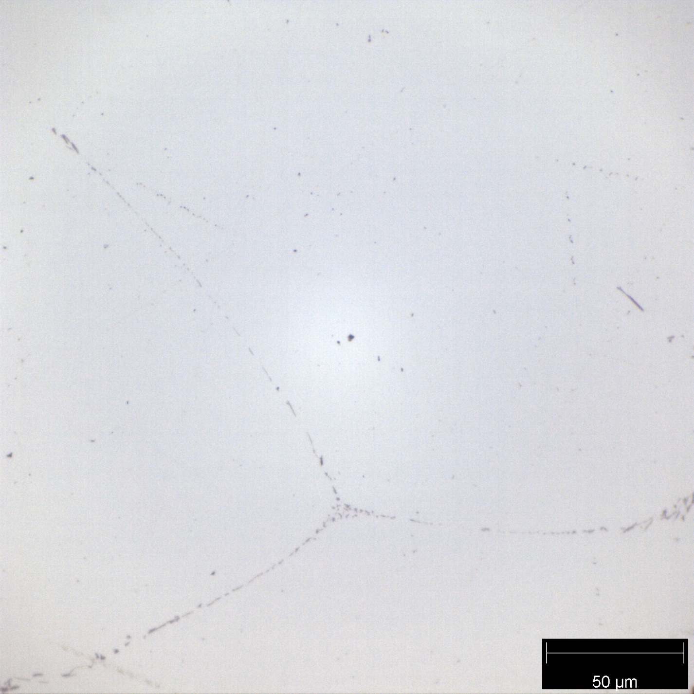Figure 2: Pure Al micrograph taken with the 50x scope. The region is all a, however trace impurities can be seen along the grain boundaries.*

Alpha(a)

This experiment uses commercial grade Aluminum, which can have a small amount of impurities inside it. These impurities can be seen along the grain boundaries. The pure Aluminum is a single phase of alpha.

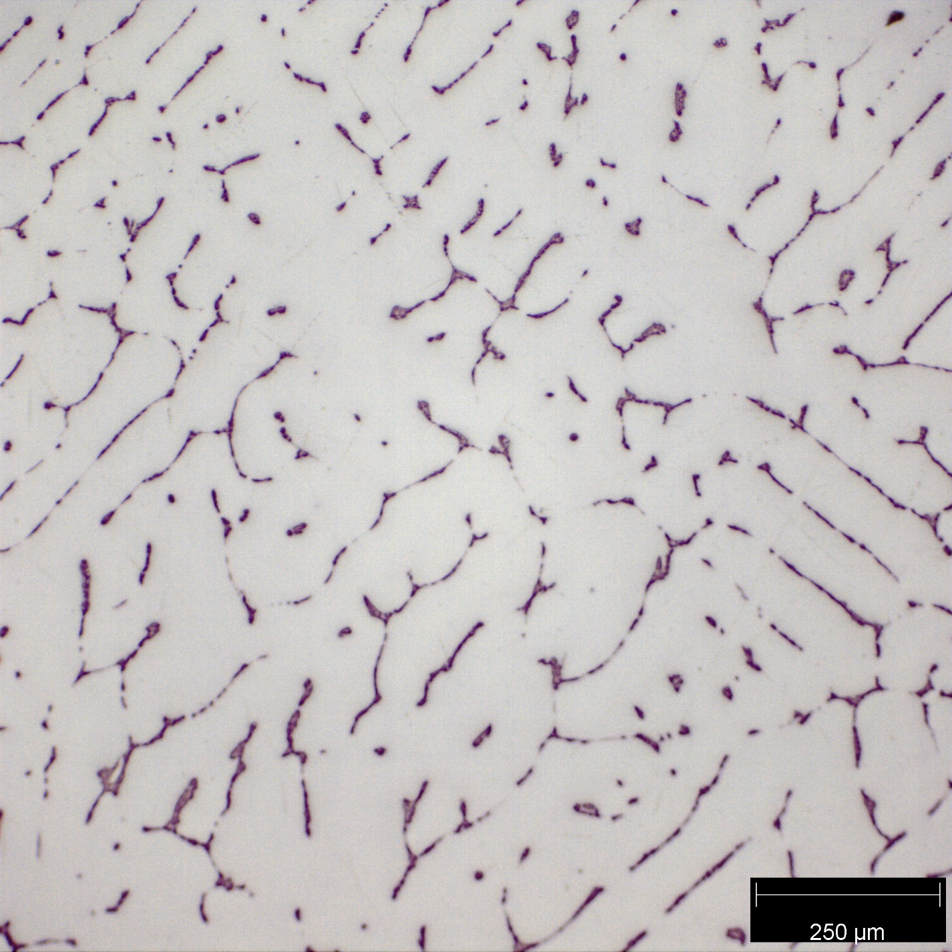

*Figure 3: Al – 4wt.% Cu micrograph taken with the 10x scope.*

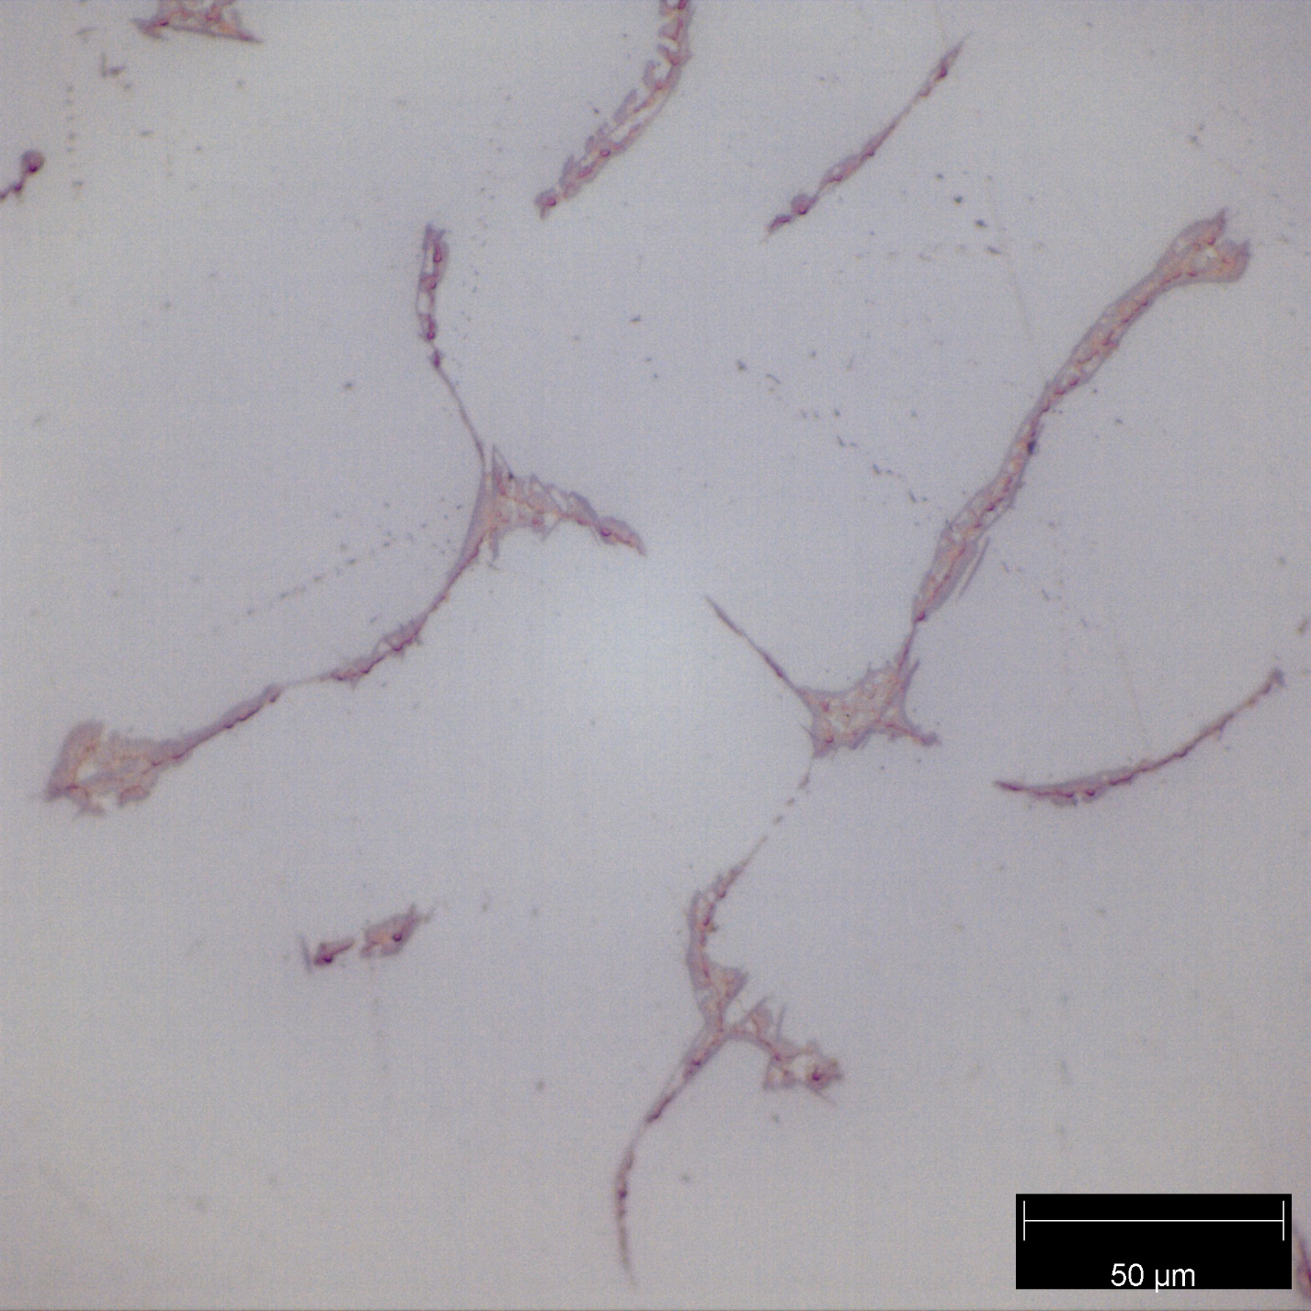

Eutectic

Alpha(a)

*Figure 4: Al – 4wt.% Cu micrograph taken with the 50x scope. The alpha phase presents as a large white region, and the eutectic material is the thin dark lines.*

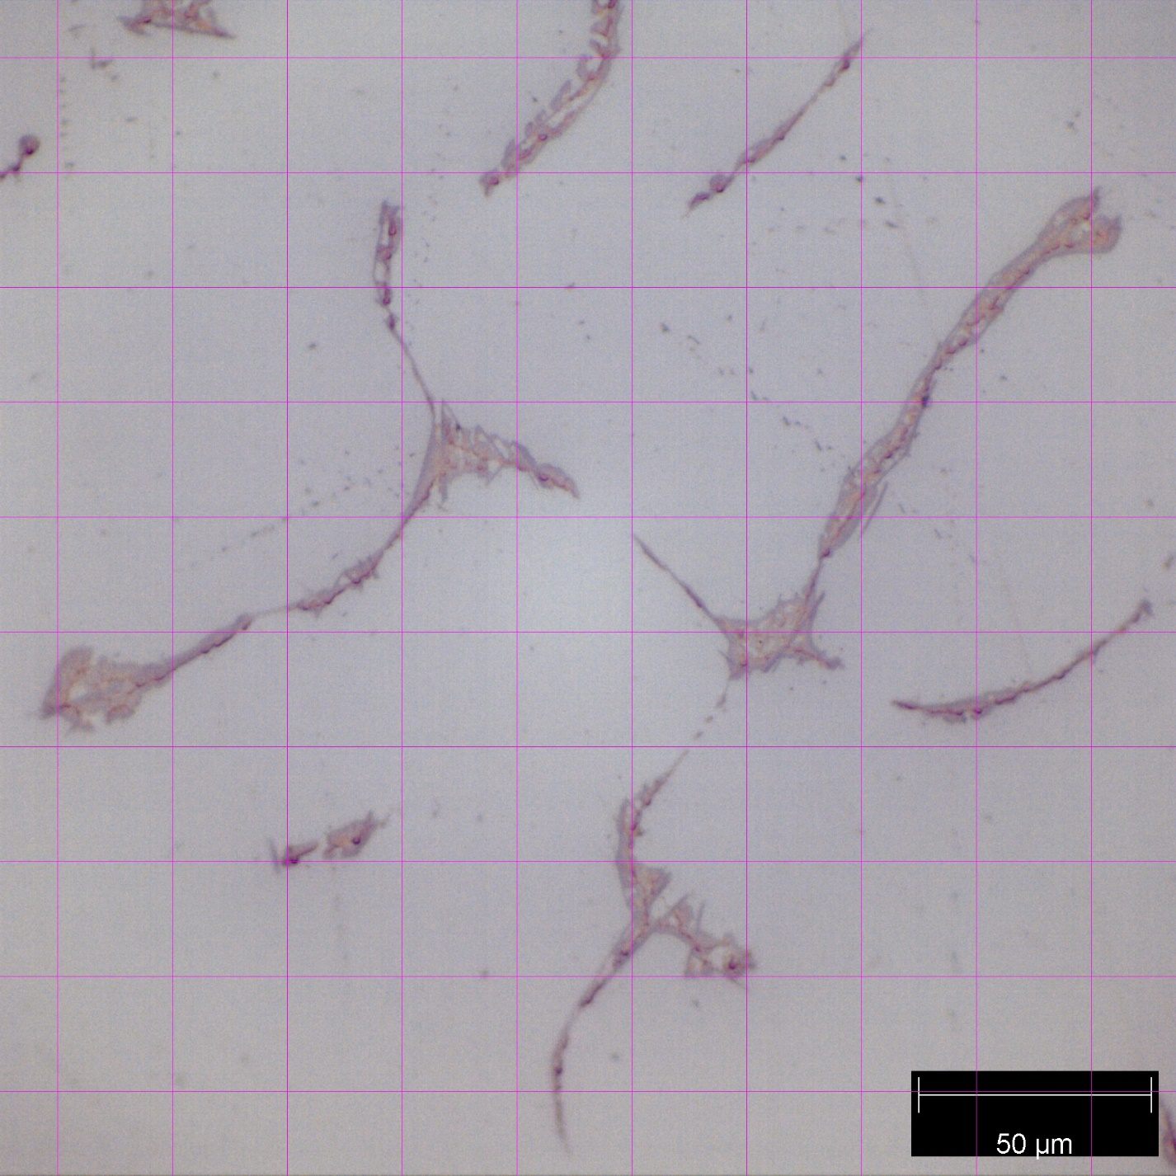

*Figure 5: Al – 4wt.% Cu micrograph taken with the 50x scope and grid added. 5.5 eutectic and 94.5 a points were counted.*

Al-4wt.% Cu contains large regions of alpha, with an outline of eutectic material at the grain boundaries. By volume %, alpha takes up 94.5% of the available space. Predictions have alpha taking up 95% of the available volume.

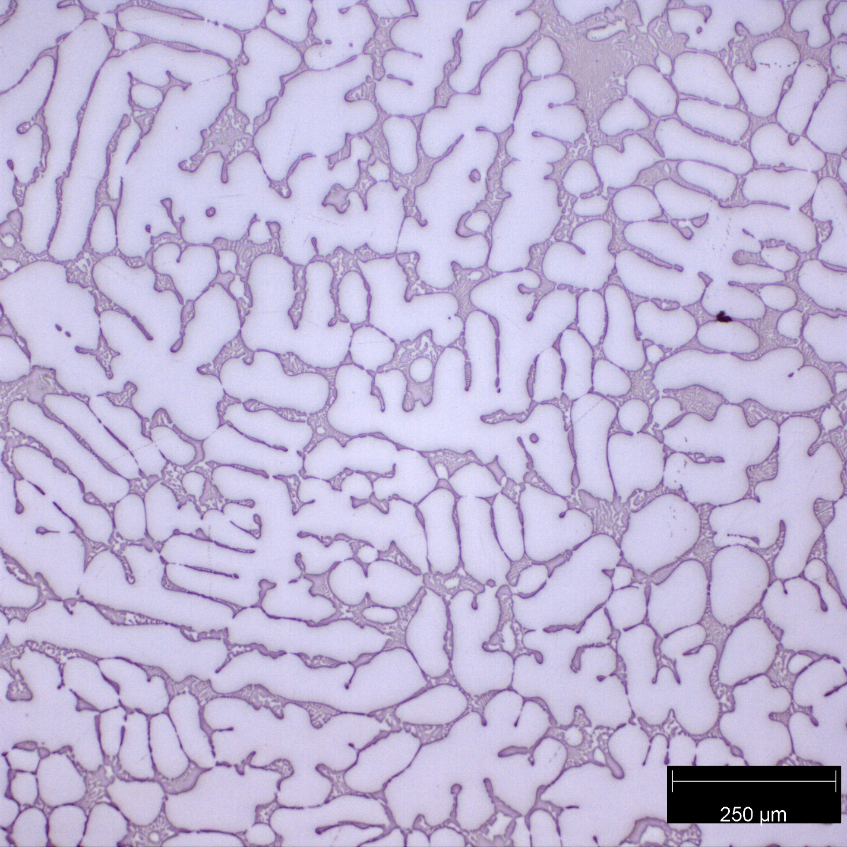

*Figure 6: Al – 15wt.% Cu micrograph taken with the 10x scope.*

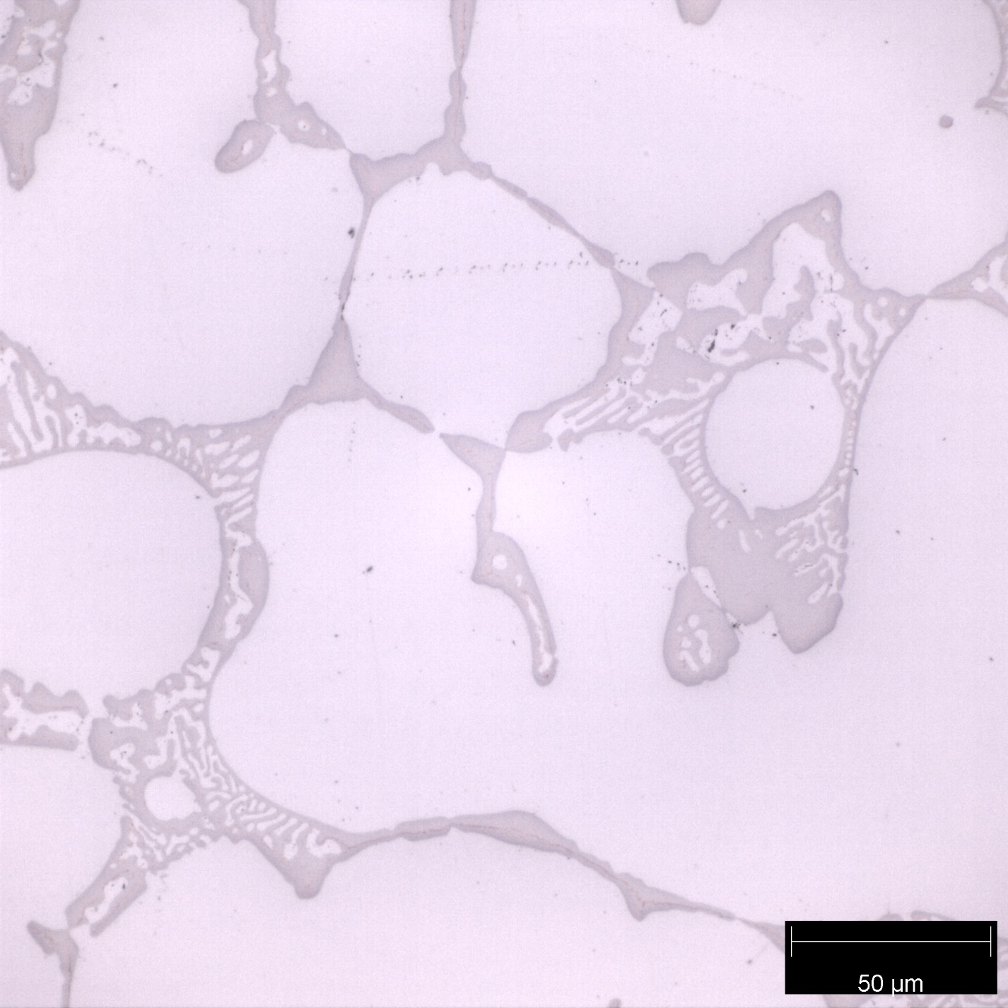

Eutectic

Alpha(a)

*Figure 7: Al – 15wt.% Cu micrograph taken with the 50x scope. The alpha phase presents as a large white region, and the eutectic material is the fine gray and white mix.*

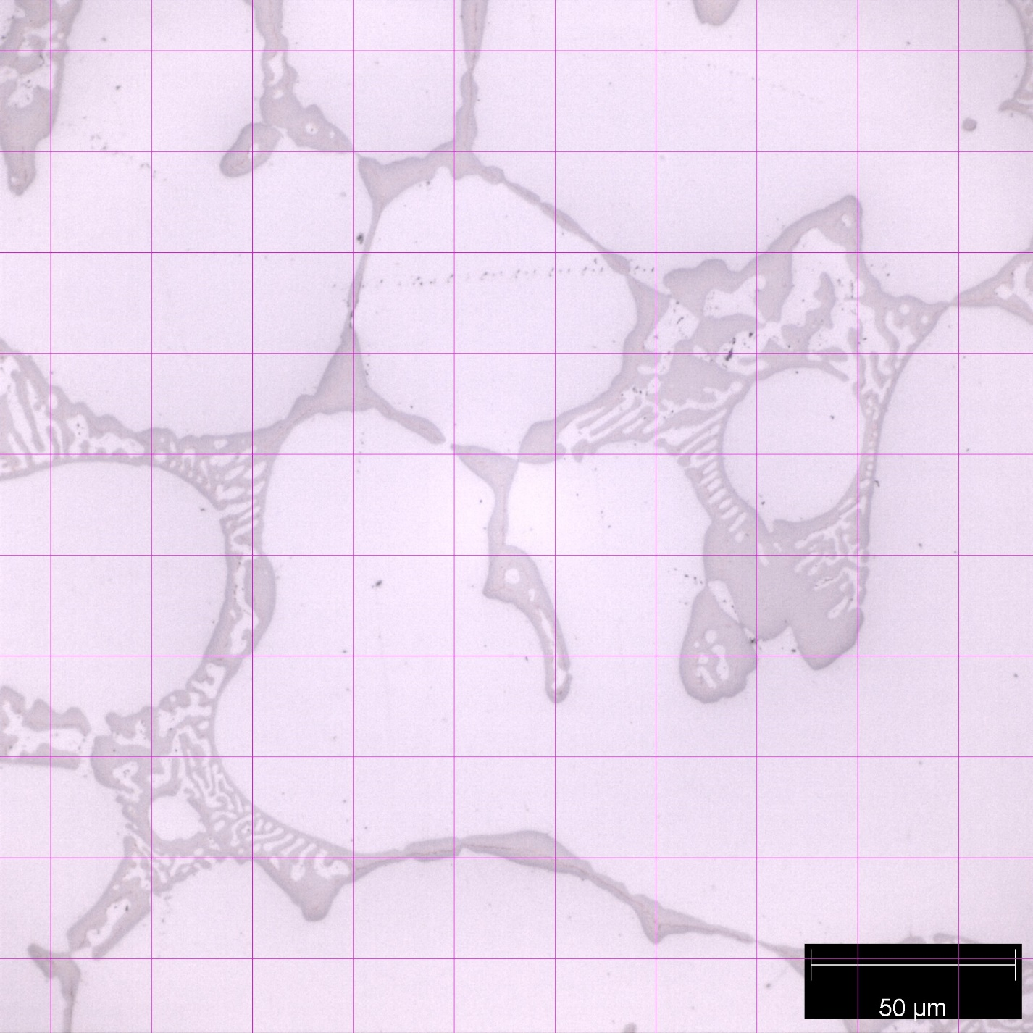

*Figure 8: Al – 15wt.% Cu micrograph taken with the 50x scope. 26 eutectic and 74 a points were counted.*

Al-15wt.% Cu contains large regions of alpha, with a white and gray mix of eutectic material between the grains. By volume %, alpha takes up 74% of the available space. Predictions have alpha taking up 72% of the available volume.

*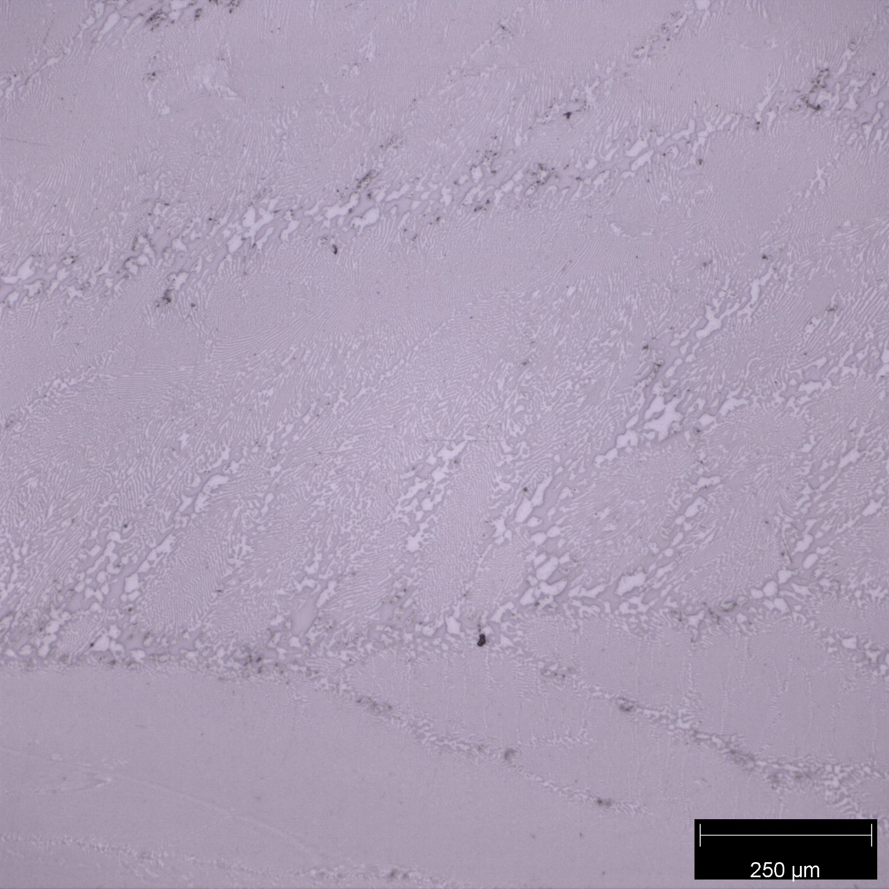 Figure 9: Al – 33wt.% Cu micrograph taken with the 10x scope.*

*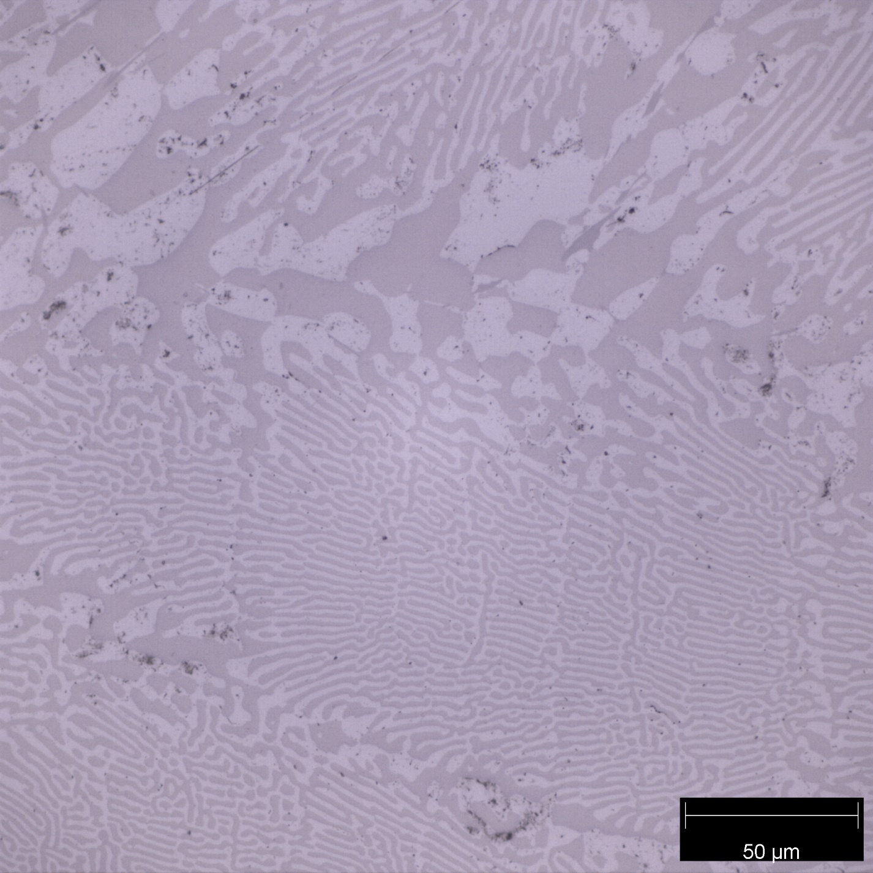 Figure 10: Al – 33wt.% Cu micrograph were taken with the 50x scope The alpha presents as a light gray color, and the theta presents as a darker gray color.*

Theta(θ)

Alpha(a)

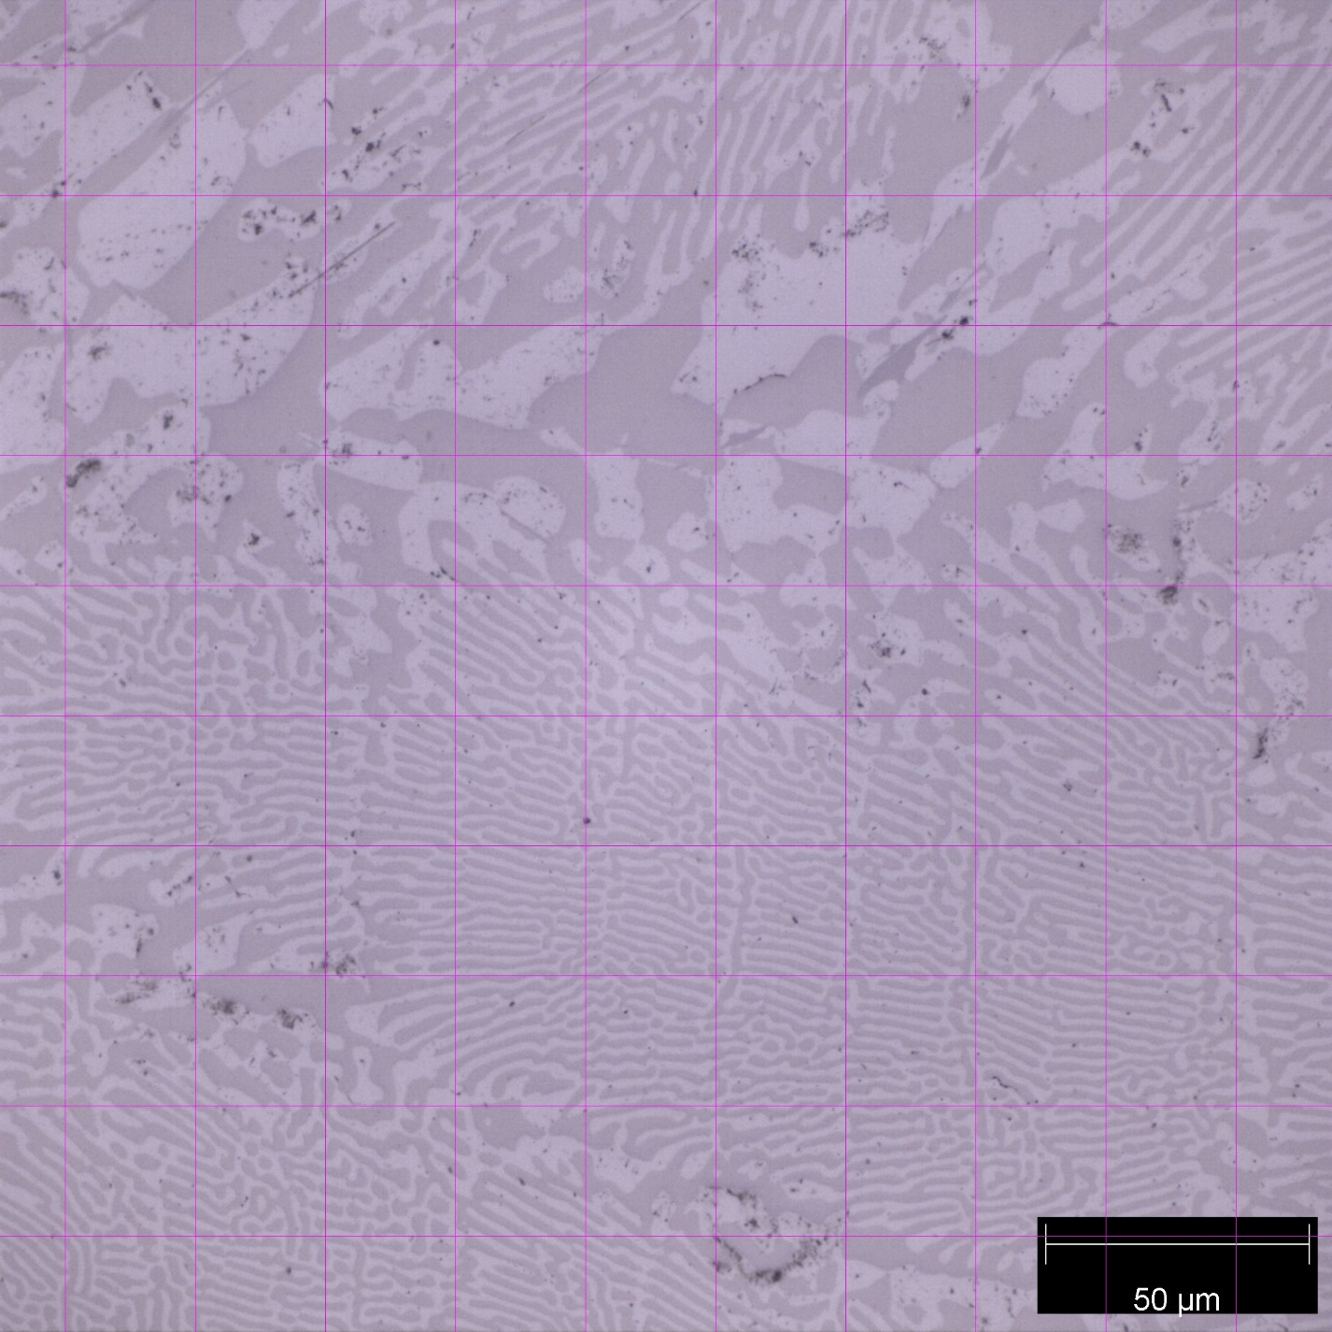

*Figure 11: Al – 33wt.% Cu micrograph taken with the 50x scope and grid. 51 a and 49 θ were counted.*

Al-33wt.% Cu is the eutectic composition for the Al/Cu system. These micrographs show entirely eutectic material. By volume %, alpha takes up 51% of the available space. Predictions have alpha taking up 51% of the available volume.

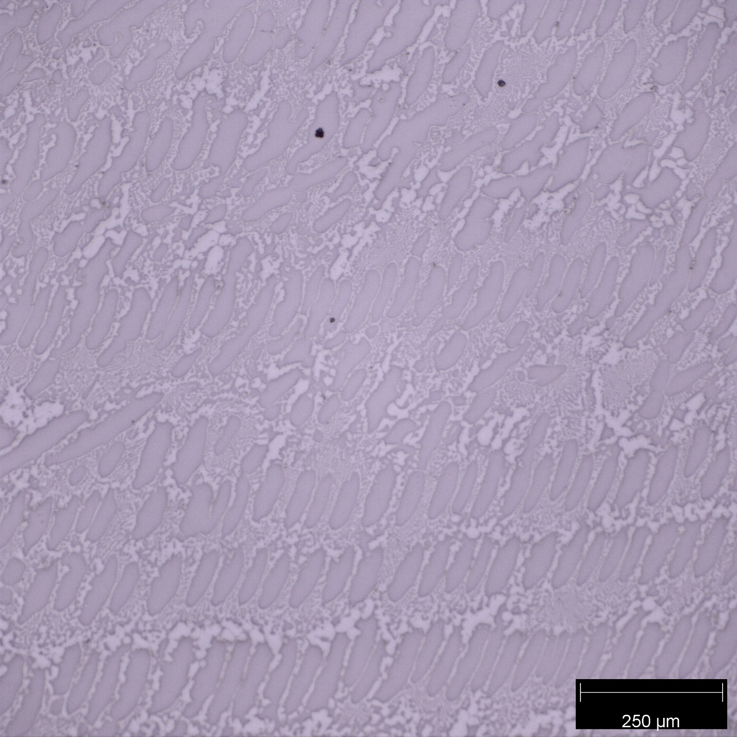

*Figure 12: Al – 40wt.% Cu micrograph taken with the 10x scope.*

*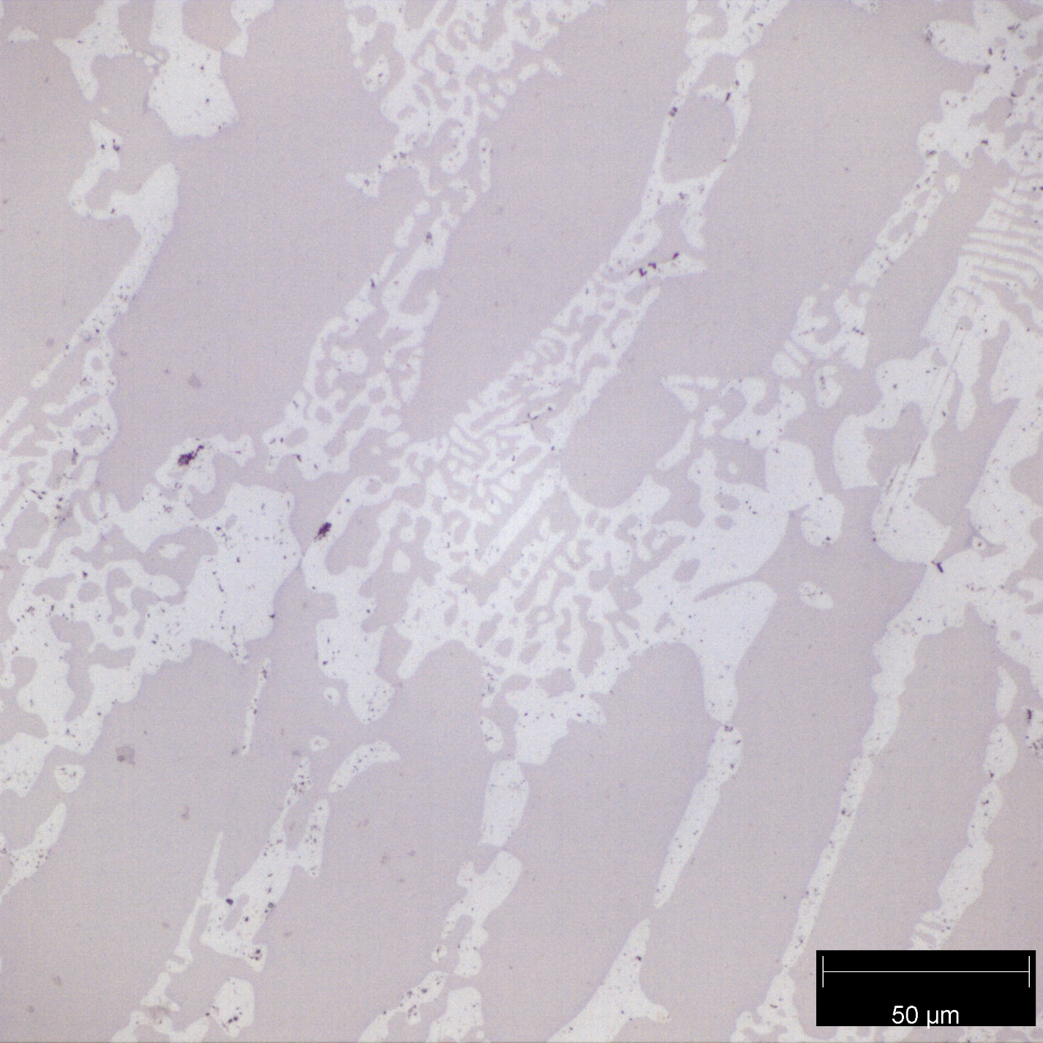 Figure 13: Al – 40wt.% Cu micrograph taken with the 50x scope. The θ phase presents as a large gray oval, and the eutectic material is the fine gray and white mix.*

Eutectic

Theta(θ)

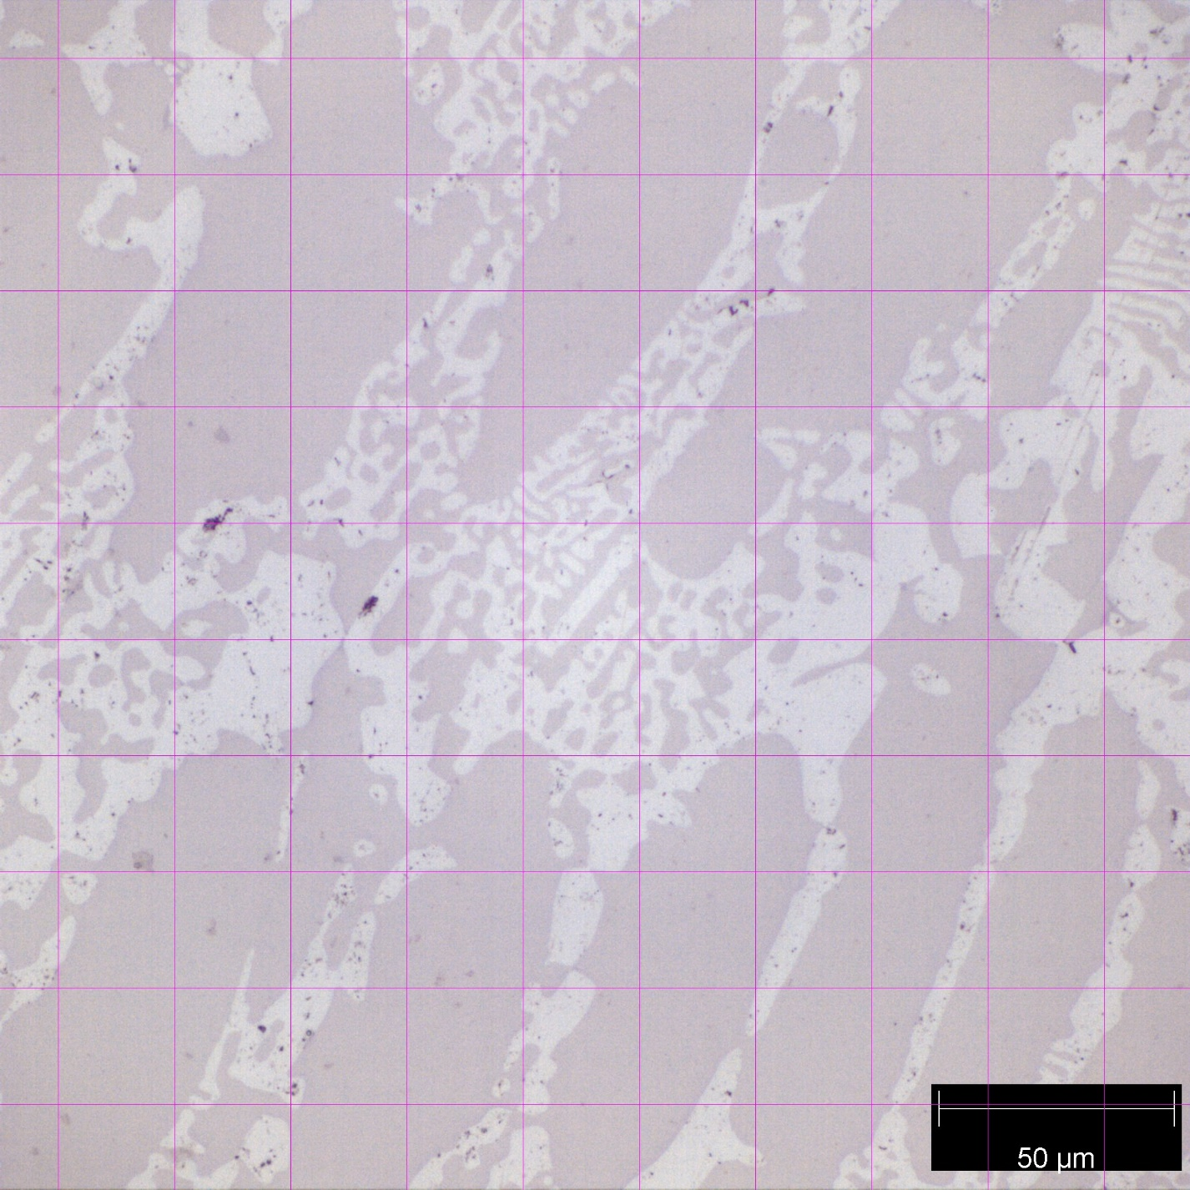

*Figure 14: Al – 40wt.% Cu micrograph taken with the 50x scope and grid. 37 eutectic and 63 θ points were counted.*

Al-40wt.% Cu contains large regions of theta, with a white and gray mix of eutectic material between the grains. By volume %, theta takes up 58% of the available space. Predictions have theta taking up 33% of the available volume.

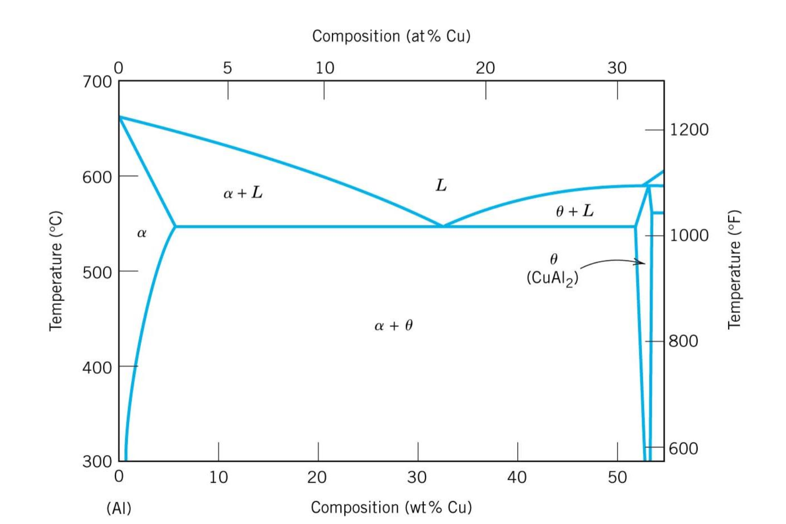

*Figure 15: Al-Rich Portion of Al-Cu Phase Diagram.*

*Figure 16: Pure Al Cooling Curve. The single-phase transformation can be seen at 656℃.*

*Figure 17: Al – 4wt.% Cu Cooling Curve. 3 phase transformation are present. They are at 646, 570, and 540℃.*

*Figure 18: Al – 15wt.% Cu Cooling Curve. 2 phase transformations are present. They are at 609 and 545℃.*

*Figure 19: Al – 33wt.% Cu Cooling Curve. 1 phase transformation is present. It is at 547℃.*

*Figure 20: Al – 40wt.% Cu Cooling Curve. 2 phase transformation are present. They are at 564 and 545℃.*

Phase transformations are exothermic during. The cooling curves provide the temperatures where these phase transformations occur. Using the known wt.% Cu and found temperatures for phase transformations a rudimentary phase diagram can be constructed.

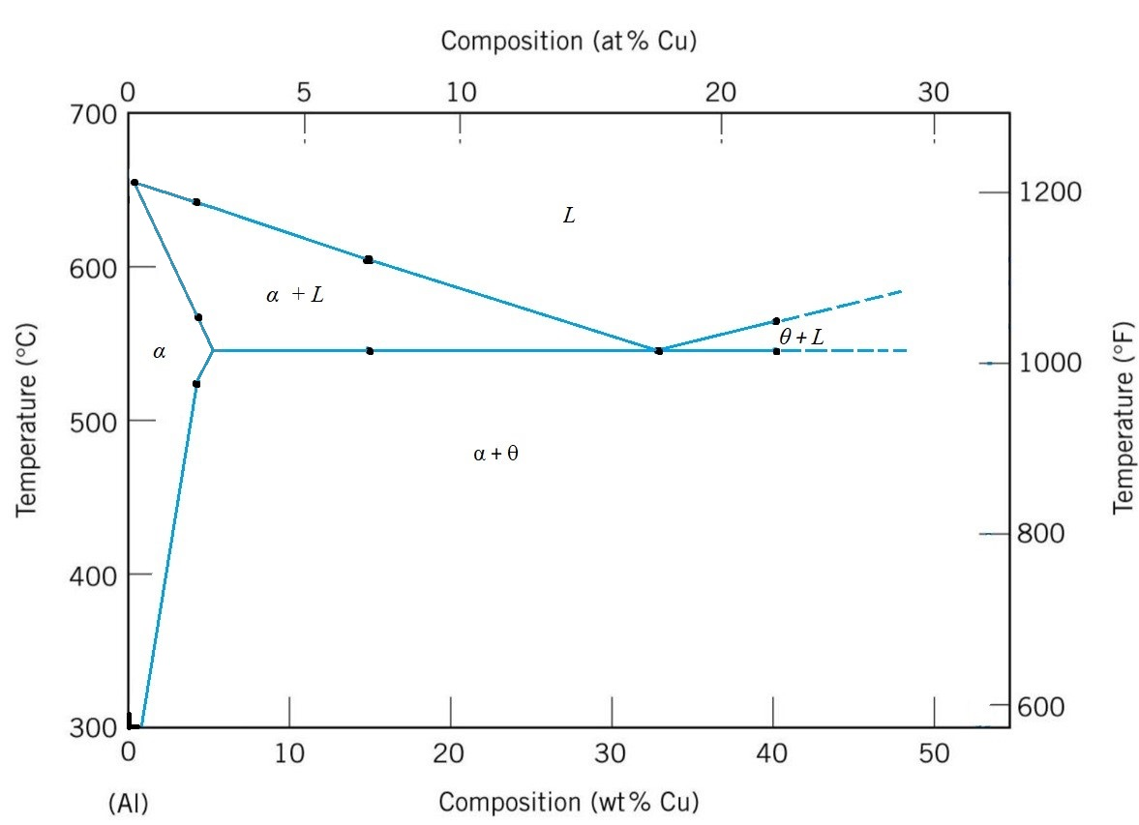

*Figure 21: Al-Rich Portion of Al-Cu Phase Diagram generated using the Al/Cu cooling curves.*

*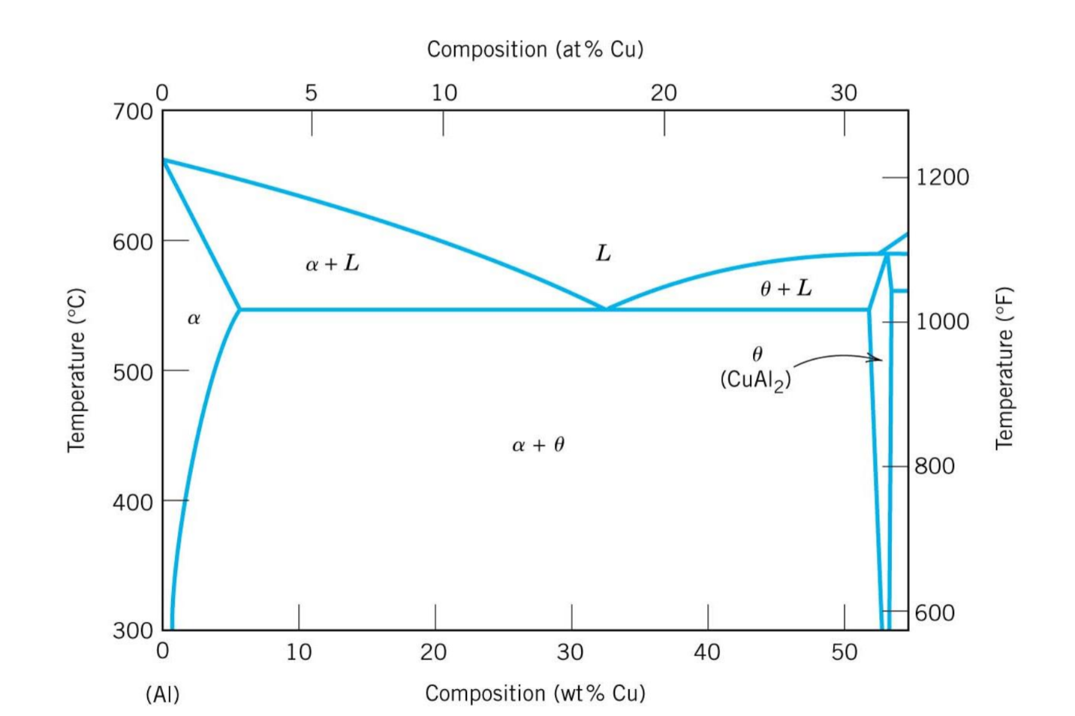Figure 22: Al-Rich Portion of Al-Cu Phase Diagram with generated phase diagram overlayed.*

The two Al/Cu phase diagrams line up very well at the eutectic temperature, and the melting temperature for pure Al. The solidus temperatures are close, however are below what they should be. Overall, the generated phase diagram is close to the actual Al/Cu phase diagram.

**Discussion**

Pure Aluminum and Al-33wt.% Cu matched up exactly compared to their predicted and counted volume %. Pure Aluminum was 100% alpha by volume, and Al-33wt.% was 51vol.% alpha (Table 1). This was due to the lack of coring that took place at those compositions. Al-15wt.% Cu and Al-4wt.% Cu differ slightly from their counted and predicted values. Al-15wt.% Cu has a counted 74vol.% alpha and a calculated 72vol.% alpha (Table 1). This difference is small and was likely due to the micrograph not being a perfect representation of the average. The Al-4wt.% Cu had a counted and calculated vol. % alpha of 94.5% and 95% respectively (Table 1). This difference agrees with a shift to the left from coring, however an unrepresentative micrograph could also be the cause for the difference. Al-40wt.% differs significantly from its predicted volume fractions. Theta was counted to be 58% of the volume, but the predicted volume percent of theta is 33% (Table 1). This departure from the predicted value is not due to coring. The 50x micrograph shows far more theta by percent than can be seen in the 10x micrograph (Figures 12 & 13). Due to non-equilibrium cooling, this location of the Al-40wt.% Cu sample contains far more theta than it should. Error could have been less of a factor if volume fraction analysis was carried out on a larger area of the sample.

The cooling curves are used to see where the phase transformation(s) for the pure Al, Al-4wt.% Cu, Al-15wt.% Cu, Al-33wt.% Cu, and Al-40wt.% Cu were at. The phase transformations can all be seen at the locations where the slope of the line changed to horizontal. The longer the horizontal line, the more latent heat that was evolved during the phase transformation. The highest temperature phase transformation for the Al-4wt.% Cu, Al-15wt.% Cu, Al-33wt.% Cu, and Al-40wt.% Cu show a small dip below the transformation at the transformation temperature. This is a sign of undercooling. Undercooling occurs due to a liquid cooling rapidly, crossing the equilibrium phase transformation temperature, but having no nucleation sites to form a solid. Before enough nucleation sites form, the temperature continues to drop. The enthalpy of fusion raises the temperature quickly to the equilibrium phase transformation temperature.

Eutectic temperatures for the cooling curves were all consistent, at very close to 545 degrees Celsius, and agree with the published phase diagram (Figure 22). The melting temperature of pure aluminum agreed with the published phase diagram as well (Figure 22). Solidus and liquidus temperatures on the cooling curves are all low compared to the published Al/Cu phase diagram (Figure 22). This error is due to coring shifting the phase diagram away from the eutectic composition on both sides.

**Conclusion**

The microstructures of pure Aluminum and Al-33wt.% Cu line up with their predicted and counted volume percent (Table 1). This is due to the lack of coring. Al-15wt.% Cu and Al-4wt.% Cu differ between their counted and predicted values. This difference is minor and is likely due to an unrepresentative micrograph of the whole microstructure. The Al-4wt.% Cu has a counted and predicted vol. % alpha of 94.5% and 95% respectively (Table 1). This difference agrees with a shift to the left due to coring, however an unrepresentative micrograph could also be the cause. Al-40wt.% differs significantly from its predicted volume fraction. Theta was counted to be 58% of the volume, but the predicted volume percent of theta is 33% (Table 1). This departure from the predicted value is due to an unrepresentative local microstructure compared to the whole microstructure.

The phase transformations for each sample can all be seen at the locations where the slope of the line temporarily became flat. The highest temperature phase transformation shows a small dip below the phase transformation, which is evidence of undercooling.

Eutectic temperatures for the cooling curves for the generated Al/Cu phase diagram agree with the published phase diagram (Figure 22). The melting temperature of pure aluminum agrees with the published phase diagram, however solidus and liquidus temperatures on the cooling curves are low compared to the published Al/Cu phase diagram (Figure 22). This error is due to coring shifting the phase diagram away from the eutectic composition on both sides. The Al/Cu system generally behaves very similar to the theoretical behavior, however cooling from liquid will need to take hours, not minutes to ensure a more consistent internal microstructure.